**Information:**

Interview conducted with Interviewee 1 (female)

30 minutes

Language spoken: English

Automatic transcription done with Zoom Audio transcription, and checked by a coder.

**Follow-up to the survey on the use of machine translation in health contexts**

**Researcher:** Thank you again for accepting to participate in this interview. As you already know, this is a follow-up interview to the questionnaire on the use of machine translation in healthcare in the Netherlands. You replied to this questionnaire earlier this year. Let me start by reminding you that this interview is being recorded. The data collected will be anonymized and analyzed together with other participants’ data. The recording itself will never be published or shared, and it will be deleted as soon as it is transcribed and anonymized. You are free to request a copy of the transcription. In the interview itself, we will invite you to go over potential scenarios regarding the use of technology - specifically, machine translation like Google translate or any other translation system on your phone or device - in healthcare contexts, like when you receive an invitation letter to get vaccinated or when you go to the doctor, huisarts.  The goal is to understand how machine translation can be used and what are the main challenges or opportunities when using it. We aim to create free training for users of machine translation like yourself in order to better support communities in these situations. The scenarios that we will show you are fictitious. They are potential scenarios or stories. The focus is on what you think a person would do if they were in this situation. Discuss anything that comes to mind or that you would like to share. We just ask you not to share confidential information about yourself.  If at any point, during the interview, you feel uncomfortable and you want to pause the interview, please just let us know. We can rephrase the question or stop the interview altogether. You can leave at any point during this interview. Any questions or concerns?

**Participant:** No.

**[STAGE 1 SLIDE 2]**

**Researcher:** I will start now by reading the first scenario that you can also see on the screen.“Two years ago, Maria moved to the Netherlands from Spain. It was right amid the pandemic, and she moved to take up a position at a new company in Rotterdam. Maria is a native speaker of Spanish, and she also speaks English. She has taken two Dutch courses online, so she understands and speaks rudimentary Dutch. For example, she can ask for a drink or have short conversations with neighbors, but not enough to feel fully comfortable speaking Dutch fluently in all situations. In 2021, she received a letter from the RIVM inviting him to get vaccinated against COVID-19. The letter is in Dutch.” What do you think about this case?

**Participant:** Oh, this case is very much a similar to my case, and then, because I understand a little bit of Dutch and I speak a very little. But yeah, so kind of similar to my situation. Yeah.

**Researcher:** What do you think Maria can do in this situation with the letter?

**Participant:** Oh, yeah, open the letter. If I were her, I would just open the letter, and then… uh, take my cell phone, and then I have an app in my cell phone, a smartphone. I have a Google Translate app. So immediately I just go [makes the gesture of taking a picture]. And then, you know, there is a function with the uh the picture so instant uh instant, um. The translation. So I would just uh just do some instant translation. Eh. You know, try to figure out what is the uh general topic about this letter, but but often this instant translation is quite, quite crappy, so I will just take a photo, and then um, you know the kind of I usually I use the the finger kind of swipe my finger and then make some areas, and then I choose to translate. And then I read the translation.

**[STAGE 2 SLIDE 3]**

**Researcher: “**Because the letter mentioned COVID-19 and vaccinatie, and Maria had been waiting for more information on when and how she could get vaccinated, it was very important for him to understand the letter completely and thoroughly in all its detail. She tackles this by trying to read the letter top to bottom, sentence by sentence. The letter is hard to understand. She does not know many of the words used, and she feels increasingly nervous.” Why do you think Maria feels this way?

**Participant:** Uh, because her health is quite important [pauses], so she doesn't want to mess up with the important information.

**Researcher:** Have you ever found yourself in a similar situation?

**Participant:** Yeah. So now, with the copy it the letter, because it is a kind of I you know it's not that it's not a life threatening thingy, so it's a fine, but when I get the uh letter from um, you know tax authority, and I feel a little bit immediate to a little bit nervous because it's about money [laughs]. So I-so far I we didn't have much uh health problems or something. So yeah, not not those. Yeah. So you know, like a covid situation. It's a pandemic, but wasn't for me so wasn't that super super serious issue to make me nervous. But for for me more likely a tax authority and or immigration documents. Those things. Yeah, those are things made me more um nervous. Yeah.

**Researcher:** What would you recommend Maria to do next?

**Participant:** Yeah, yes, scan. And then you use a Google at uh, look at the Google Translate and um, and often, but I found that often it is a little bit uh, well, I found Google translated it quite good. But often I didn't feel like that I fully understand it because I guess it's cultural differences. So somehow, way of expression-expressing something where some words that they use somehow. I guess it's a very much a Dutch context, so probably Dutch people would understand it, so natural, but for me sometimes. So I I I didn't get it actually. So what… But what is this mean? Because also, Google Translate sometimes they do the literal translation, and then that doesn't make sense to me, and I try to. Then I just try to even more, because I don't, usually I don't want to read in a line by line, so I just to scan it. And then so okay, they just want me to get uh vaccine or not. And then. Yeah, if I need a more information, I go to uh their website. Sometimes the website is quite good, but all also I found that often Dutch way of building website is a kind of different from my own culture. You know some other. You know something that the system that I am used to. So it's a more like a little bit hard to navigate. So they navigate why did they put those things here and where do I have to go. So a little bit often I waste my time, like five to ten minutes to navigate where I have to go. Kind of thing Yeah. So what would I? Yeah.

**[STAGE 3 SLIDE 4]**

**Researcher: “**Maria decides to use Google Translate. She opens the app on her phone, and using the camera, she scans the letter. It is rather challenging.” How would you say her user experience with the app is?

**Participant:** Um! How do I know? I'm not her so [laughs].

**Researcher:** What kind of problems do you think she might face with this technology?

**Participant:** Um, I guess it depends on her level of comfort using app. So he-she already knew how to use it probably she wouldn't have any difficulties, I would say; but if she is a, if Maria is older person, then she may have a little bit of uh problems because you usually uh you got older somehow we are not really sharp enough to learn new things, right? Especially with the devices. So I guess it depends on her age. If Maria is a younger lady like in her twenties or thirties, she would feel more okay. Forties I think, I think, is quite okay. But if she is a more than four, forty, or fifty, fifty, or sixty, she may have some challenges.

**Researcher:** Have you ever found yourself in a similar situation?

**Participant:** Um, Not much.

**[STAGE 4 SLIDE 5]**

**Researcher: “**Maria is able to make an appointment for her vaccination. On the day of her appointment at the vaccination center, she goes to the counter, where she is asked in Dutch to present her ID and letter of invitation. She manages to understand this because the person on the counter makes a sign of the ID with her hand. Maria is nervous. Next, she is asked to fill in a health questionnaire in Dutch.” What would you recommend Maria to do next?

**Participant:** Uh, speak English [laughs], because Dutch people lot of them they have, you know good English. So I often found that [pauses] yeah, um, if I don't understand actually, if I don't understand, I just speak English, and then they just help you in English so. But if I can understand to their Dutch, I I try to use Dutch, but often I end up speaking English because I don't want to, you know, pull out my cell phone and then using Google translate in person, so usually I just switch to English.

**[STAGE 5 SLIDES 6-8]**

**Researcher:** “Because she has some knowledge of Dutch, and the first questions in the form do not appear to be difficult, such as *Naam,* *Achternaam*, Maria tries to answer them in Dutch. On the second page, though, she reads three questions she does not understand. She does not understand questions 11, 12 and 13.”

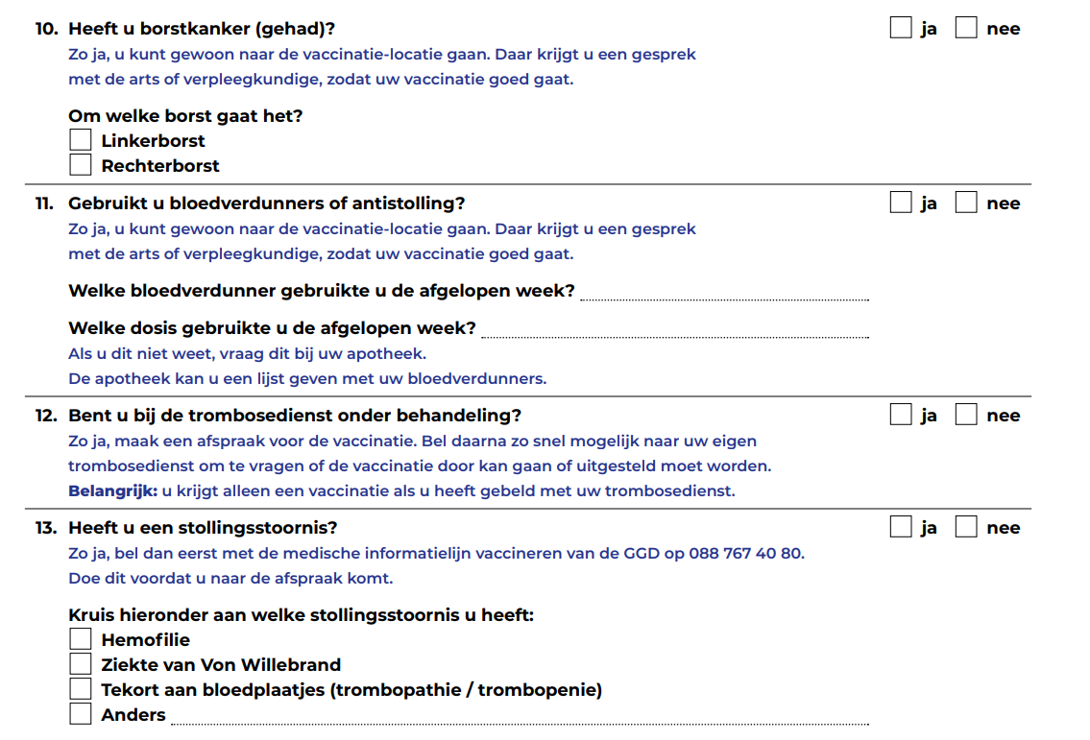

**Researcher:** What would you recommend Maria to do next?

**Participant:** Uh, pull out her cell phone, and then use the translation app.

**Researcher:** Have you ever found yourself in a similar situation?

**Participant:** Yeah, all the time.

**[STAGE 6 SLIDE 9]**

**Researcher:** “Maria asks for help from the young man behind the counter. She asks in Dutch if she can explain what is “bloedverdunners of antistolling”,  “trombosedienst onder behandeling”, and “stollingsstoornis” by pointing at the form with her finger. The young man looks surprised. She looks at the next counter, and it is empty. She looks behind, and everyone seems busy. She then tries to start a sentence a couple of times and finally says in English that these are diseases.”What would you recommend Maria to do next?

**Participant:** To do next? Is it…

**Researcher:** What would Maria do next, or a person in this situation would do next?

**Participant:** So I Oh, yeah, she's a Port- Portuguese. So what is her. It's the assumption is, Maria she has. She can speak English or not?

**Researcher:** She can. Yes.

**Participant:** Yeah. But I think if she can, speaking English already, probably [pauses] she wouldn't ask help from the young lady- Dutch lady because if I were her I would just use Google translate, and probably I would find that it is a disease, and then I would do uh quickly using Google. It's a little bit googling about that, this is, and then, yeah, What is is that disease? And I will make my own, uh, decision I guess.

**Researcher:** Have you ever found yourself in a similar situation?

**Participant:** Uh, no because when of course some questionnaire I have lots of words that I don’t know, some medical terms and disease. But I don’t ask help from Dutch people because they will, they may know the name of the disease in English. But even though, even if they say something in English, I may not know what is that disease, right? So probably I need to Googling anyways, so I wouldn't ask help, but rather I just go directly to go to Google Google Googling.

**[STAGE 7 SLIDE 10]**

**Researcher:** “Maria turns to her phone, opens the Google Translate app, and types the words she does not understand.”In your opinion, is Maria taking a risk by using Google Translate?

**Participant:** I think it has a little bit of risk. But if you, Googling, the, uh the name of the disease, and then and then name of the disease, and then often if I want to understand, I go to you know. You know. There, there's a Wikipedia [laughs]. It's always go back to the Wikipedia, and then I read it through quickly, you know. Scan Wikipedia, and then I understand what kind of disease it is, right? Yeah. So I think that it's enough. I don't think I think a medical professional, so they have a very better, deeper knowledge but in on-site I don't think that they would explain more than Wikipedia.

**[STAGE 8 SLIDE 11-15]**

**Researcher: “**Maria turns to her phone, opens the Google Translate app, and types the words she does not understand.”

We are going to use a scale for the following questions:

5 = to a very high degree

4 = to a high degree

3 = to a moderate degree

2 = to a low degree

1 = not at all

Is the scale clear?

**Participant:** [Nods, confirming.]

**Researcher:** What level of understanding do you think Maria has when using the app? Does Maria understand the text…

5 = to a very high degree

4 = to a high degree

3 = to a moderate degree

2 = to a low degree

1 = not at all

**Participant:** You mean the letter or some question that…?

**Researcher:** The text of the questionnaire.

**Participant:** I think, she would have a three.

**Researcher:** What degree of risk of significant harm is Maria exposed to if using the app? Is Maria’s health at risk?

5 = to a very high degree

4 = to a high degree

3 = to a moderate degree

2 = to a low degree

1 = not at all

**Participant:** Hm. [unintelligible] If it is a vaccination, it is a… I would say three, because the letter is not the only information we can receive. But I think, if it is a more serious illness, like a cancer, cancer, or something more serious, that you need a immediate operation, I think, using Google translate and those apps, uh would… I think that would be more risk here than vaccination. I would say, if we did say case of cancer, or some operation, I would say, at risk of degree of risk, would be, I think, four.

**Researcher:** What degree of trust should Maria have in these translations? Should Maria trust these translations?

5 = to a very high degree

4 = to a high degree

3 = to a moderate degree

2 = to a low degree

1 = not at all

**Participant:** Um yeah I think, in terms of vaccination, I think four.

**Researcher:** What degree of vulnerability do you think Maria has while using the app? Is Maria at risk of being vulnerable?

5 = to a very high degree

4 = to a high degree

3 = to a moderate degree

2 = to a low degree

1 = not at all

**Participant:** In the vaccination situation I think three.

**Researcher:** Are there any other comments about this scenario or related scenarios you can think of?

**Participant:** Oh, not really, but a if, she said, because the, the assumption is, Maria is a from Portugal, and that she can speak English. So I think that that makes a little bit easier. But some language like Korean. Um, actually, I use Google translate Dutch to English. Somehow I found that Dutch and English to have a more similarity, so the translation is a more little bit um, better. I mean a little bit more accurate than uh a Korean translation. Let's say. So I use I I just use Dutch and English, so it's a quite okay. But I know some Korean ladies, they don't they they speak a little bit of Korean, but some ladies their-their English is not really good, and they put Google translate Dutch to Korean, and then I see that it's okay, actually, not bad. Not bad, but little bit, I think that some level of miss translation is a higher chance than Dutch to English. So in the medical situation, those Korean ladies has a little bit more vulnerable situation, and they they have a little bit more of um problems.

**[Training - follow-up questions – SLIDES 16-17]**

**Researcher:** Before we end the interview, we also wanted to ask you what sort of training on using these machine translation apps you would find helpful.

What type of information on machine translation would make your life easier when using these apps in health contexts?

For instance, do you feel you need more instructions on how to use the apps? Can you give us an example?

What about information about how to deal with the translations themselves? Do you have an example?

Would it be helpful to understand better the instances when machine translation is not advisable?

**Participant:** Yeah, Because I don't. Yeah, I think it's a very useful [laughs] by the way. Helpful because I'm using this Google translate every day. By the way, almost every day. So not only my cell phone, also I receive a lot of information through email, and sometimes I have to go to Dutch websites, and then let's just say some ordering some food for delivery. Or doing some online shopping. Yeah, try. I try to not to do online shopping, but sometimes I have to do it. Then, when it comes as Dutch, although I have a little bit of bit of Dutch, I can understand a little bit, still actually see seeing those a Dutch website actually increase a lot of stress level to me [laughs], so actually very stressful to seeing these in websites. And then you made it to like. If they have option of English. I always immediately go to um English website. If they don't have option, You know. Google Chrome has some um translation. So I just immediately I go to English translation. And then, somehow, psychologically, I have a little bit better inner peace [laughs]. So it's true inner peace. But now, recently, my computer computer, I had some little bit of problem, So I had to reinstall. And then because I bought this computer in the Netherlands, somehow default somehow in the Netherlands. So I have to. I changed. I I thought that I changed everything in the Netherlands, but still some functions coming with Dutch. So I I spent one or two hours to change all the functions to English, but it was so stressful. Actually, I got eventually so angry [laughs]. So I couldn't is keep going back to some Dutch so angry. But anyways, Yeah. So So those motion translation as it helps me a lot, and then saving my time a lot as well. And also those translation app is not perfect, but still keep reduce my level of stress. But it's always. But it's not not really not that sometimes it's not that easy, because if some Google Chrome or some other things not immediately, automatically translate then I have to, I have to try to find the button or I have to put out my cell phone, and then do manually, you know, to choose it. And that is actually sometimes too annoying, by the way. So I sometimes I hope that yeah, I don't know, you know. Sometimes I hope that. Can I reduce those one more step a little bit faster.

**Researcher:** Do you maybe feel that for instance instructions on how to do this would help?

**Participant:** Instruction? No, not really. Humm. I don't read instructions.

**Researcher:** What about information about how to deal with the translations themselves?

**Participant:** um, information about how to deal with the translation themselves, you mean myself right? Yeah, so sometimes, I yeah I sometimes I feel that I get lost in translation, because this is some literal translation. And then let's say some medical terms I don't know, and then it has some, also the cultural differences as well, so like it sometimes they use some that um kind of the you know (pauses) vaccine or needle. These they use a ‘prik’ or something. And then, somehow, the literal translation is all weird. Just sounds very odd. Um. But of course I have a little bit of knowledge, so I can guess. But-but-but always, I feel like that i'm a little bit like an oil in the water. That is my feeling. And but what can I do?

**Researcher:** Would it be helpful to understand better the instances when machine translation is not advisable? Would you think this would be helpful for you?

**Participant:** I guess so (pauses), yeah. And also in the medical situation it’s not about me- uh motion translation, probably the website that you should have all different languages. And um, of course it's… Hold on. When machine translation it’s not advisable. Yeah, I think so. Okay. If I'm. In this situation I have these options, or perhaps I should do this or that. I can't choose other things. Perhaps. Yeah, I think that is a good reminder otherwise. Although we all aware it's not perfect. But if we see that, uh in this the medical blah blah context, the motion {machine} translation, it's not advisable. If you do it on your own risk or something, then people probably ‘oh right’, a reminder. Yeah, I didn't think about it. But I think it's a good thing.

**Researcher:** And how would this be helpful? So would it be helpful to have a website with short videos, or Youtube? You've already said that you don't like instructions. But how? How can we give you this information? For instance; would you prefer free in person training? Would you prefer a video?

**Participant:** But to be honest, even if it is happening in in person, I don't think I will attend. Everyone is busy. Right? But if some people who are attending some programs, let us say some Dutch class, or some some classes they have to go through. Maybe it's not a bad idea to, um, have a short sess- session with them.

**Researcher:** That's a very good advice.

**Participant:** Yeah, or or even I'm thinking that even you can (pauses) make, because there are some, there are many different Dutch classes, right? So some are kind of government or city so subsidized. So maybe it's not a big idea to make um class materials, so they can learn about this this contents as a Dutch learning materials. Or listen to short video during the class.

**Researcher:** Yes, thank you. That's very helpful.

**Participant:** By the way. So, personally, I don't think I will watch the short video, or step by step, guide either. Maybe there there is the infographic. Maybe I will take a look, but usually infographic doesn’t convey much information by the way so. I'm a little bit lazy so.

**[Closing]**

**Researcher:** Thank you for participating in our research. Our times of analysis and publication are long, but feel free to write to us to obtain the results of this research. Otherwise, we will contact you with the results in due time.